Take home quiz - due Monday, October 7, 2019

Unit 1, Lesson 1: Tiling the Plane
Write your best definition of area.

Unit 1, Lesson 2: Finding Area by Decomposing and Rearranging
The square in the middle has an area of 1 square unit. What is the area of the entire rectangle in square units? Explain your reasoning.

Unit 1, Lesson 3: Reasoning to Find Area
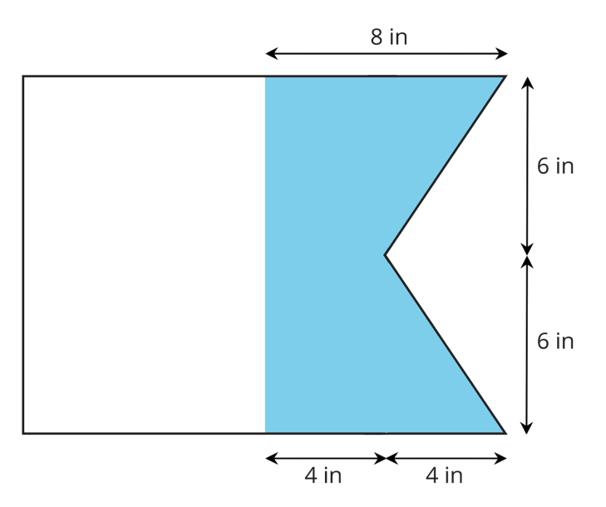
A maritime flag is shown. What is the area of the shaded part of the flag? Explain or show your reasoning.

Unit 1, Lesson 4: Parallelograms
How would you find the area of this parallelogram? Describe your strategy.
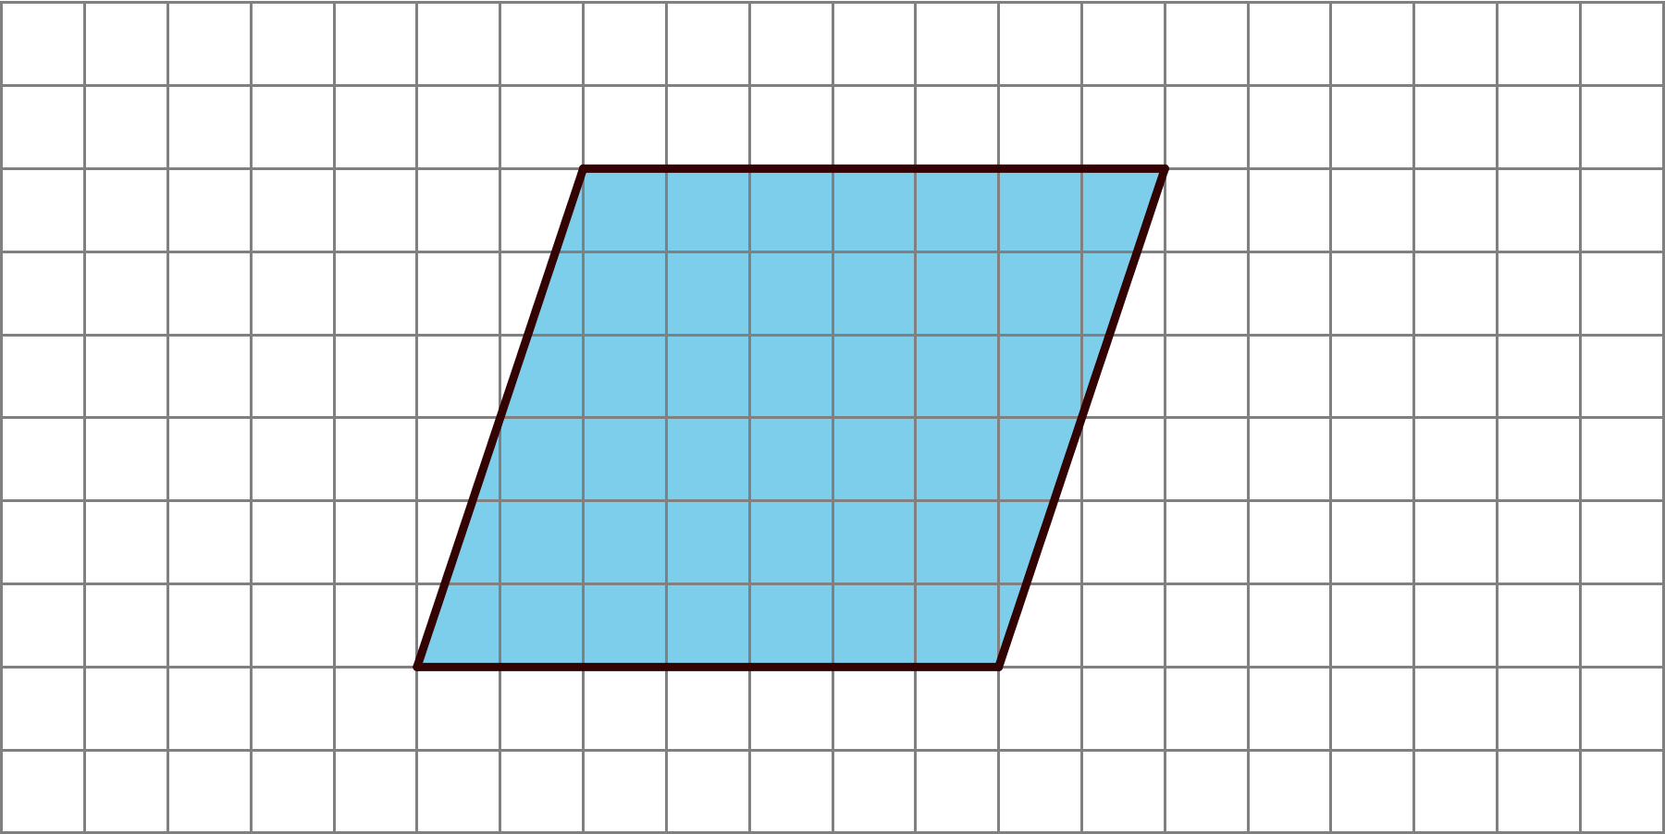

Unit 1, Lesson 5: Bases and Heights of Parallelograms
Parallelograms S and T are each labeled with a base and a corresponding height.
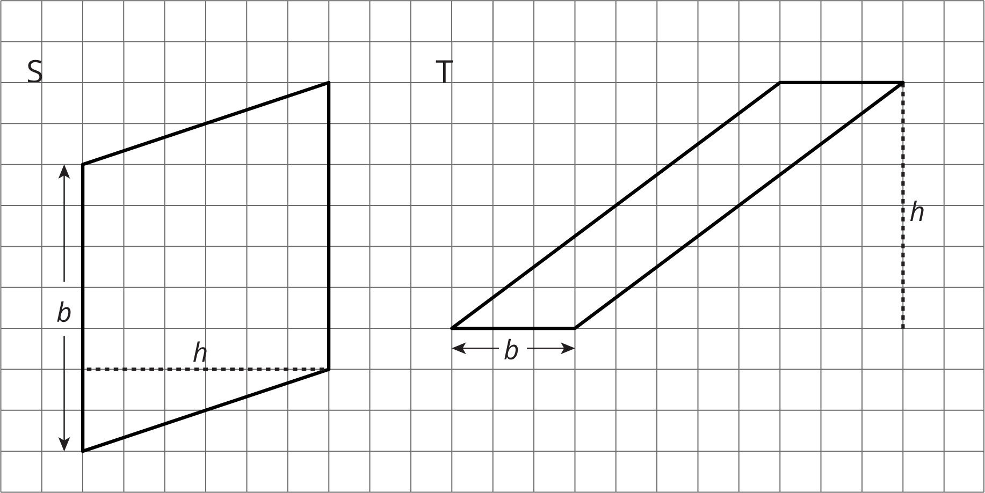
- What are the values of $b$ and $h$ for each parallelogram?
  - Parallelogram S: $b$ = _________, $h$ = _________
  - Parallelogram T: $b$ = _________, $h$ = _________
- Use the values of $b$ and $h$ to find the area of each parallelogram.
  - Area of Parallelogram S:
  - Area of Parallelogram T:

