Unit 1: Mid-Unit Assessment Study Guide
For all grids, each small square on the grid has an area of one square unit unless otherwise indicated.
- Which parallelogram has an area of 80 square units?

- Select all the triangles that have an area of 40 square units.
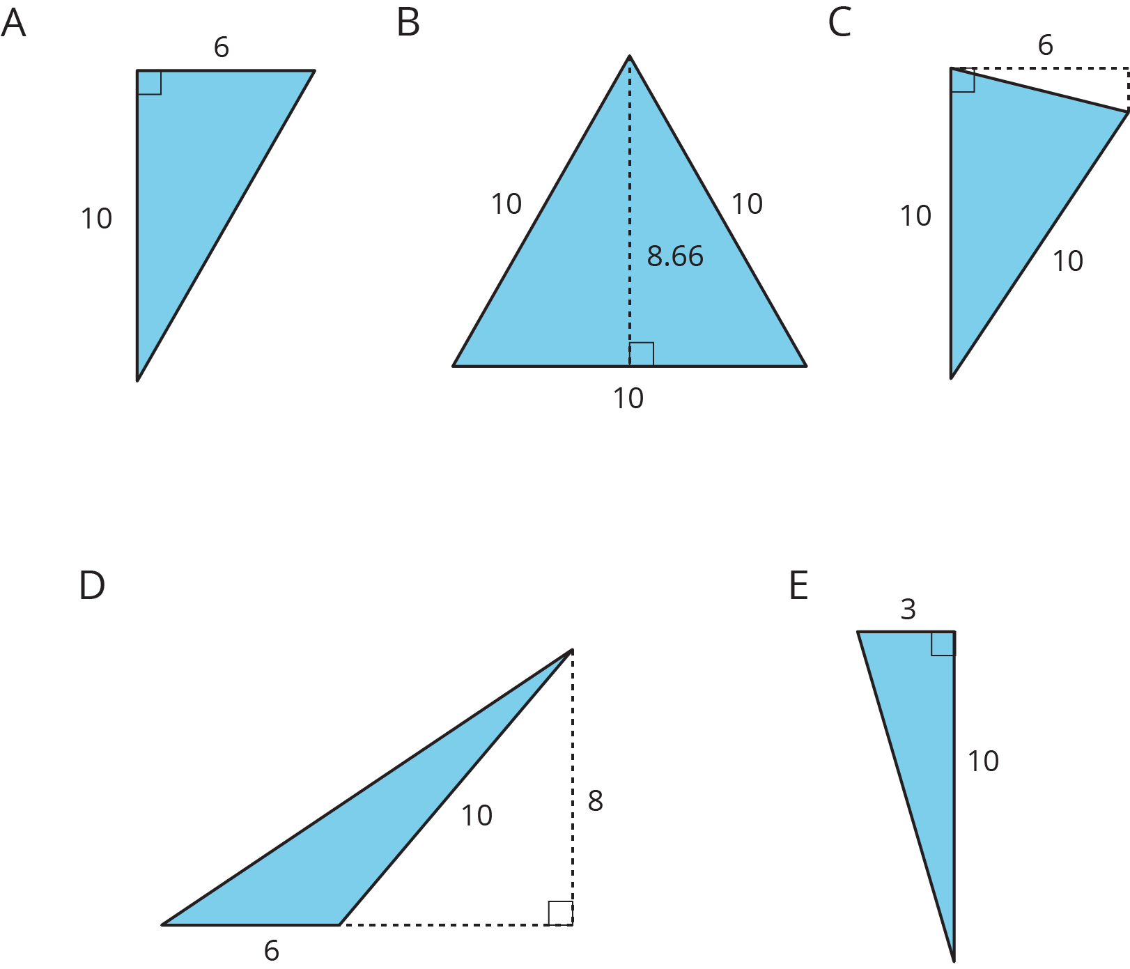
- Select all the parallelograms that have an area of 16 square units.

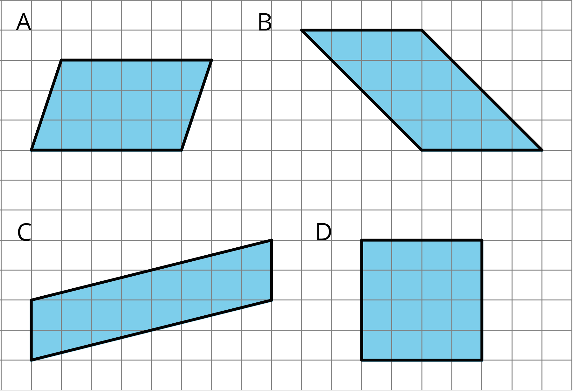

- On each triangle, draw a segment to represent the height that corresponds to the given base. Label each height with the word “height.”

base
base

- Draw two distinct parallelograms, both with areas of 18 square units. The two parallelograms should not be identical copies of each other.

- Find the area of the given figure. Explain your reasoning.
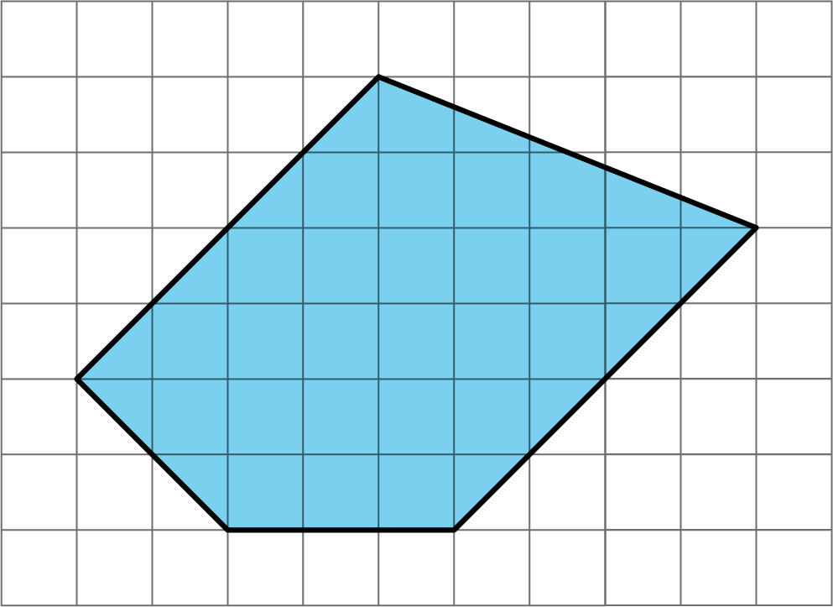

- The figure is a diagram of a wall. Lengths are given in feet.
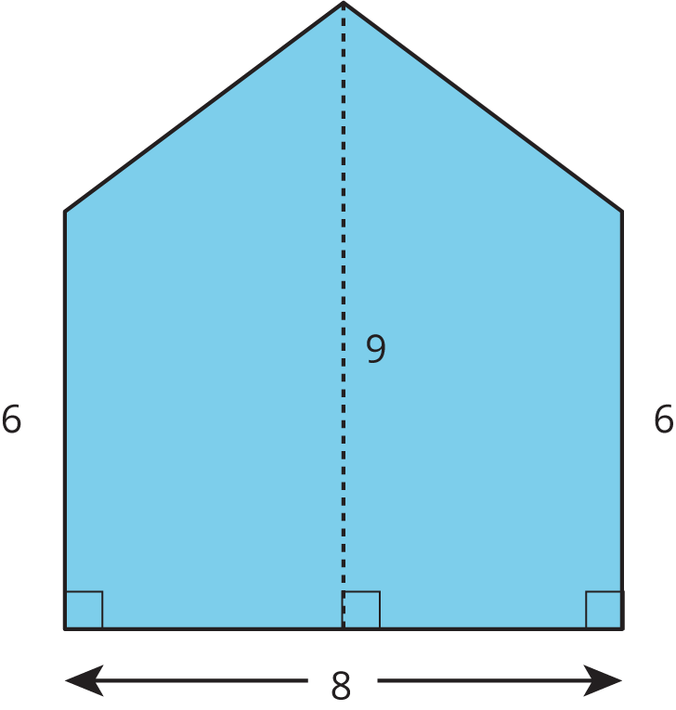

  - How many square feet of wallpaper would be needed to cover the wall? Explain your reasoning.

  - Wallpaper is sold in rolls that are 2 feet wide. What is the minimum length you would need to purchase to cover the wall?

